**Manage Questions**

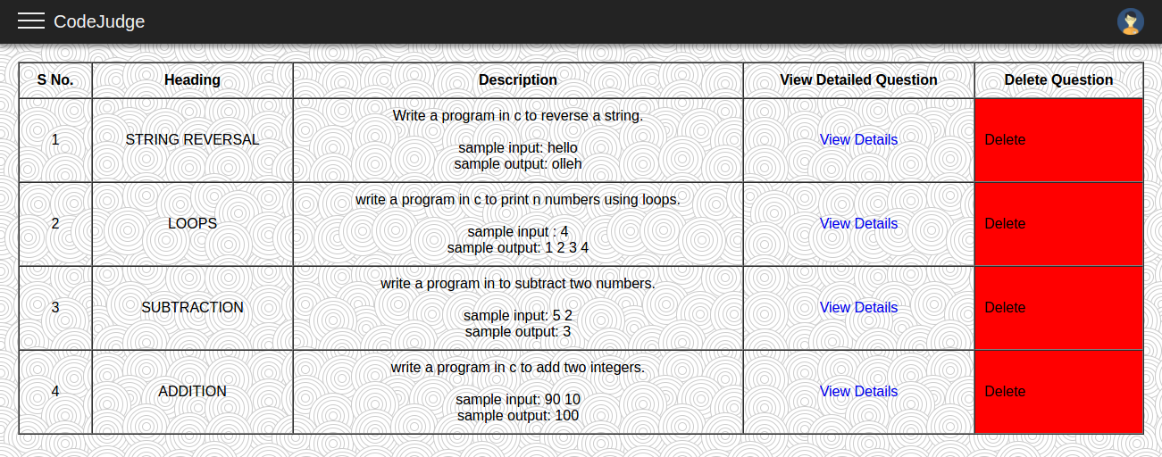This page shows the functionality possessed by the teacher/examiner i.e. to check the number and type of questions uploaded by them as well as the freedom to delete any question which is no importance further in the system and reducing load from the database of the system.

Fig. 4.9: Manage Questions

This page is visible only for the teacher, examiner or similar role possessing person in the system. Different teachers will have different questions on this page according to their history of uploading the question. So, this page is user specific and particularly for the users having role of teacher or examiner.

**4.1.4 CODING PLATFORM**

**Text Editor Window**

This is the text editor window for the students or the candidates participating in any coding challenge or simply attempting practice question before any practical examination. The window shows the objective of the program while writing the code on it as well as suggests sample input and output values to the users.

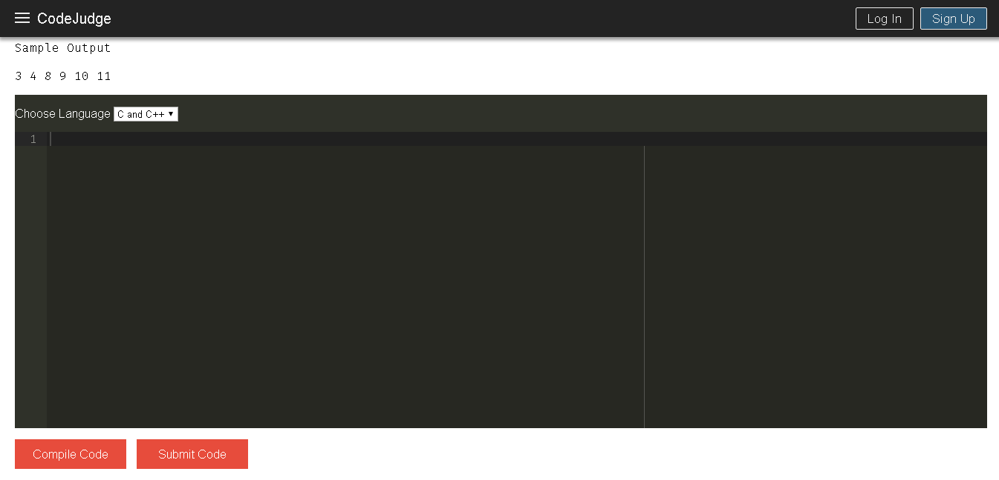Fig. 4.10: Text Editor

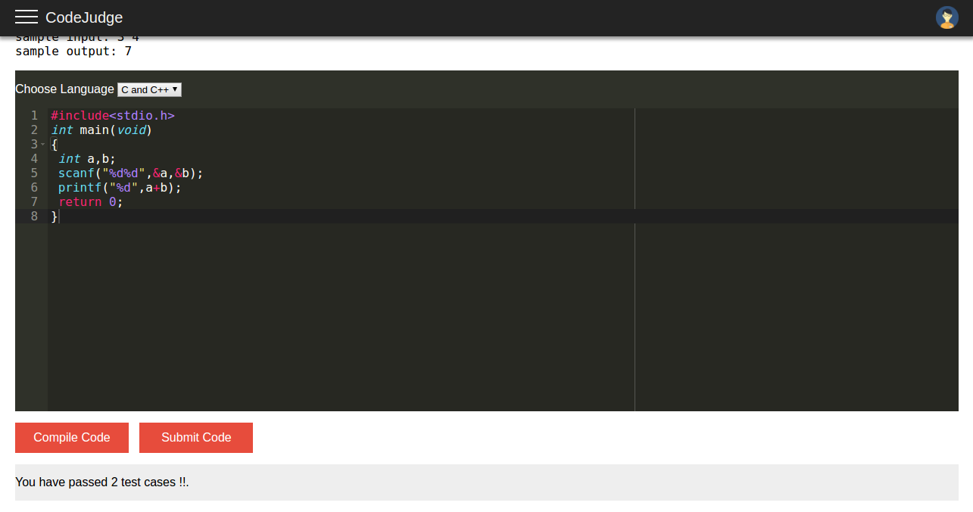It is shown on the text editor window only that how many test cases are passed after writing and compiling the code. If the contestant finds everything fine then he can click on the submit button.

Fig. 4.11: Test Cases Passed

**4.2 IMPLEMENTATION**

Every time new software is developed, developers have to maintain version and configuration related documentation. The implementation shows us how much brain storming is performed in the backend to bring in the present compact and easy to use version of user interface.

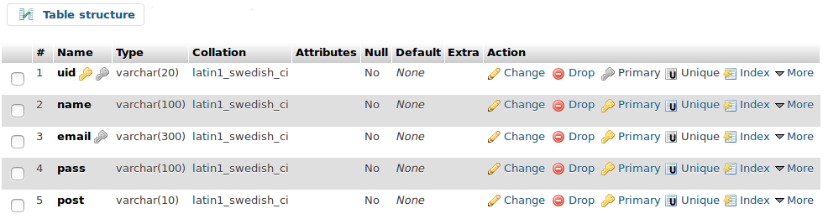 Fig. 4.12: Registered Users

Implementation shows us how complexly things are connected and have been maintained to give the project its current structure or current form.

The following images will give you a glimpse of how the database is build, managed and maintained for the system by showing important tables having different fields.

The above described table shows how registered users are maintained in the database, from the fields available it is clear that a unique id is maintained for every user.